Welcome to the registration wiki!

step1:

<https://github.com/kasaraneniamulya/registration/blob/master/source/registration(2)(1).html>

Created a web page that provides option for choosing career option, different levels of education and semester with drop down lists.

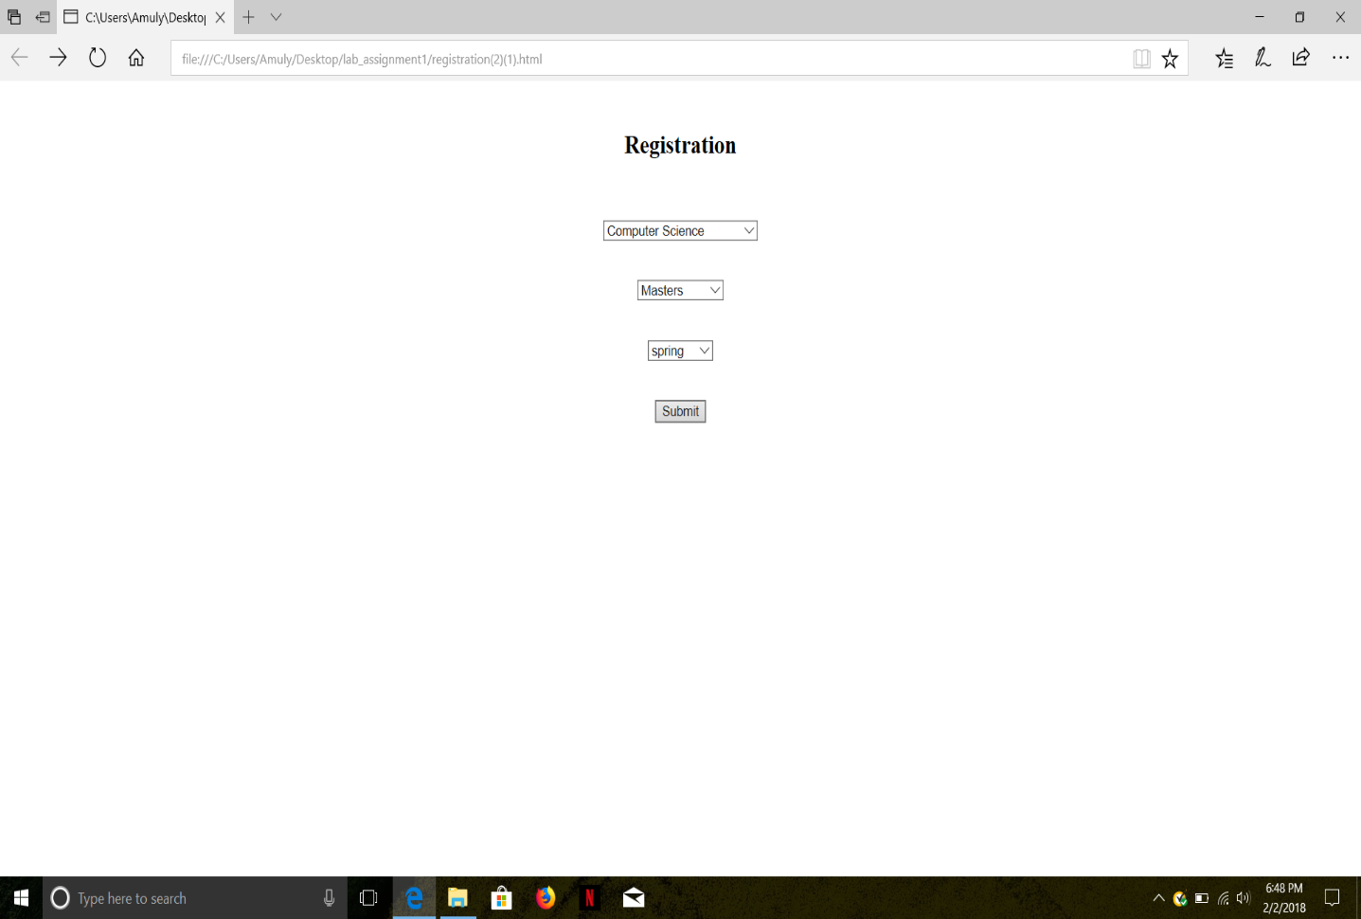

step2: <https://github.com/kasaraneniamulya/registration/blob/master/source/Instructor.html>

When we select submit button with the desired combination(computer science, masters, spring) it would redirect to the page that contain information about the courses that are offered in this semester, prerequisites for each course, credit hours, duration and the corresponding faculty dealing that course. 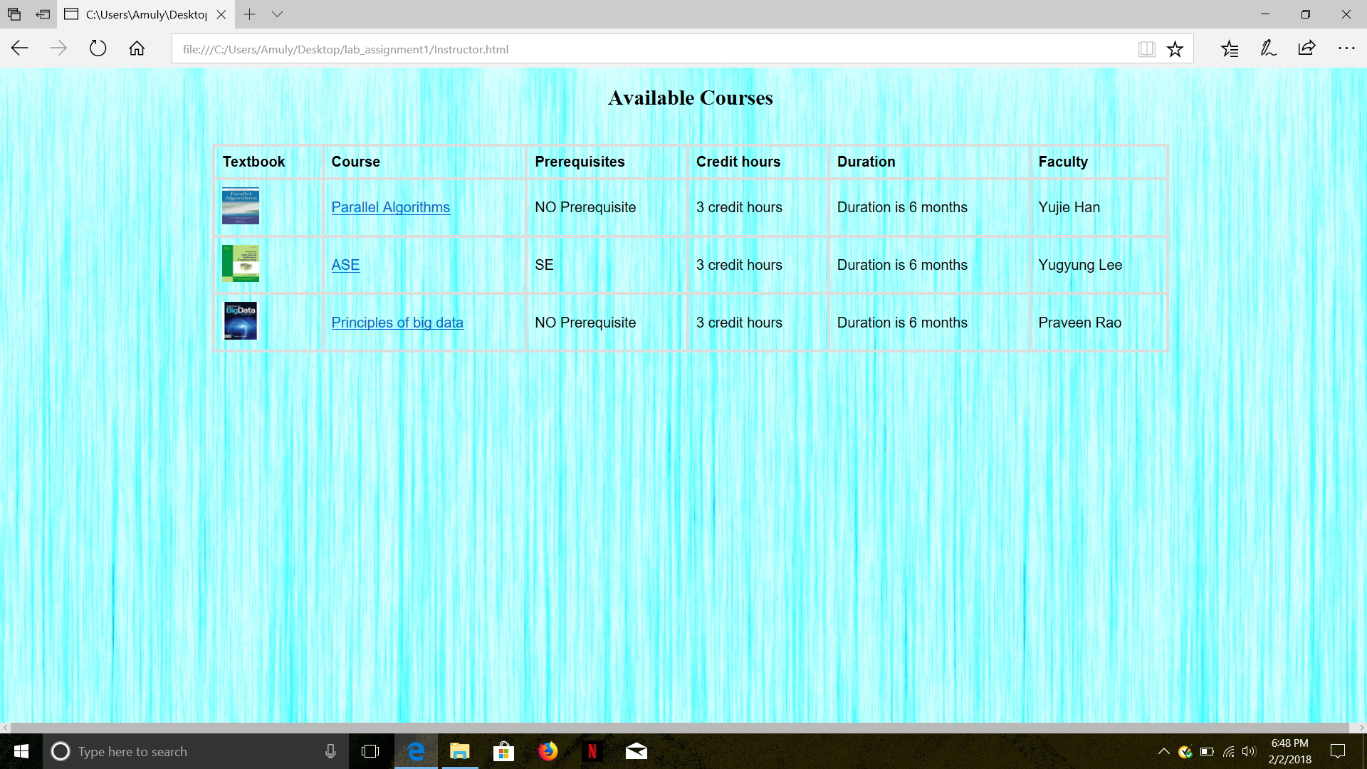

step3:

<https://github.com/kasaraneniamulya/registration/blob/master/source/Course1.html>

 If we select any of the course description hyperlink or textbook image it will provide details of available seats and a page for registration. 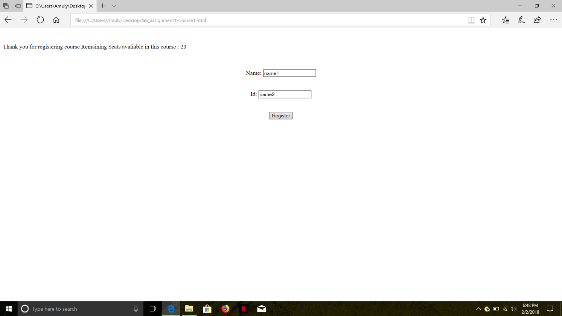

Step4: When a person gets registered by clicking register button automatically the available seats will get reduce.  :

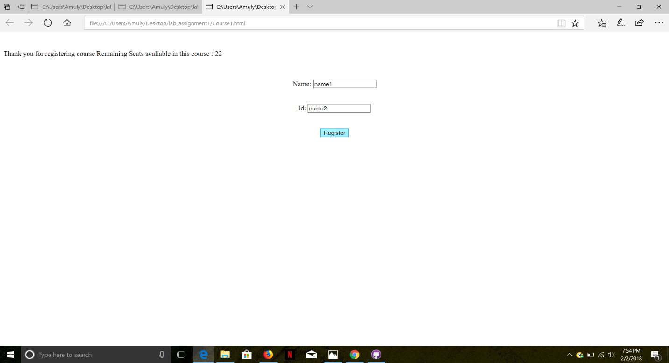

get

The above steps are same even for other streams. Step1:

<https://github.com/kasaraneniamulya/registration/blob/master/source/registration(2)(1).html> 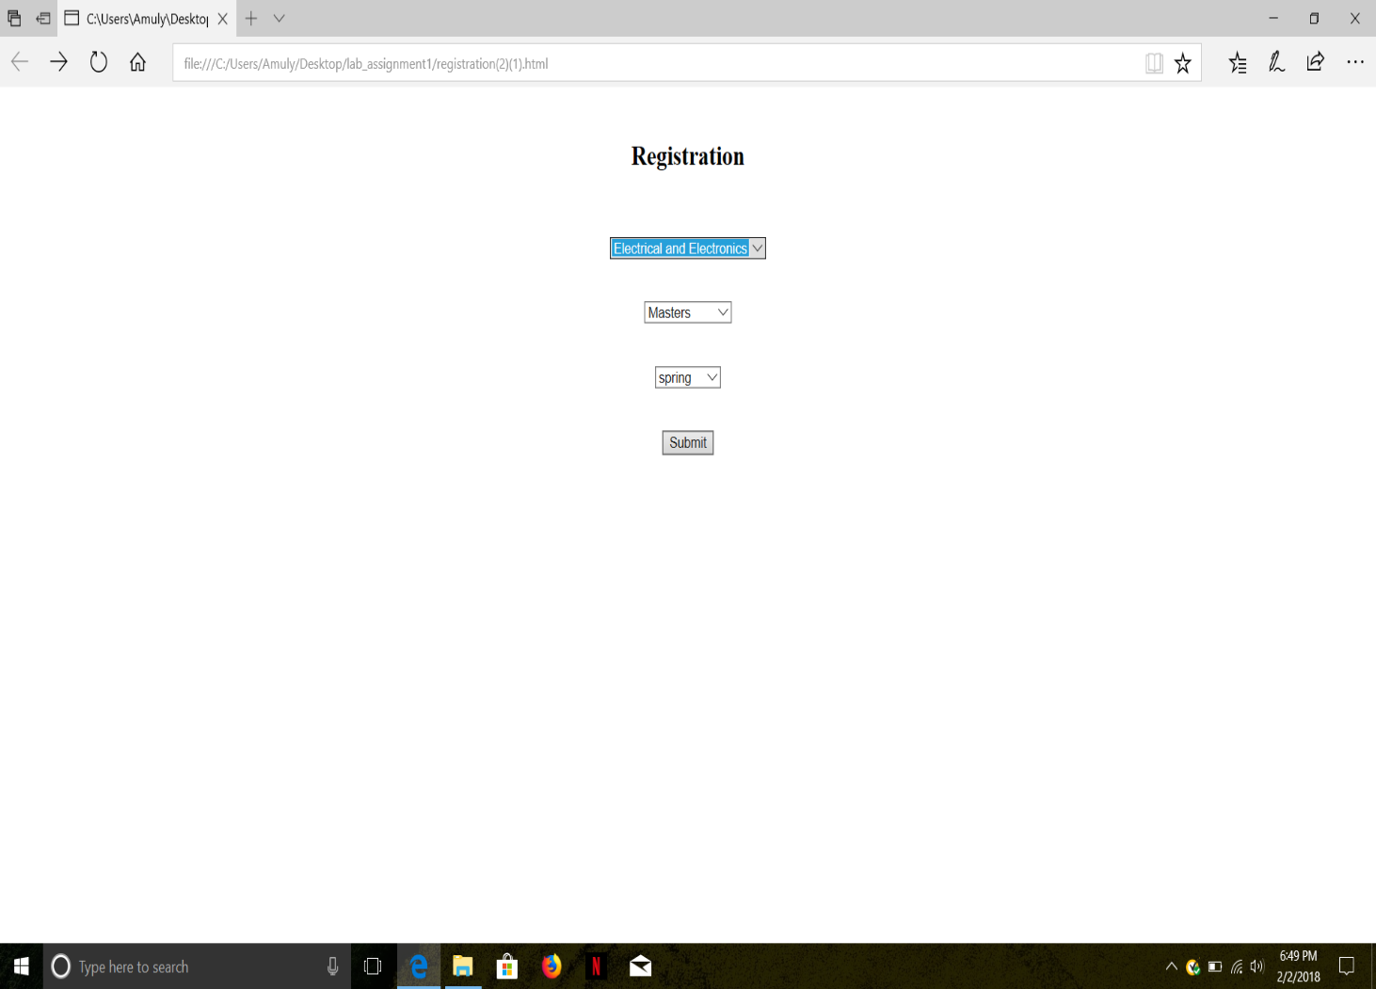Step2: <https://github.com/kasaraneniamulya/registration/blob/master/source/professor.html> 